STARFIRE S-4

CHASSIS MOUNTED BROOM SWEEPER

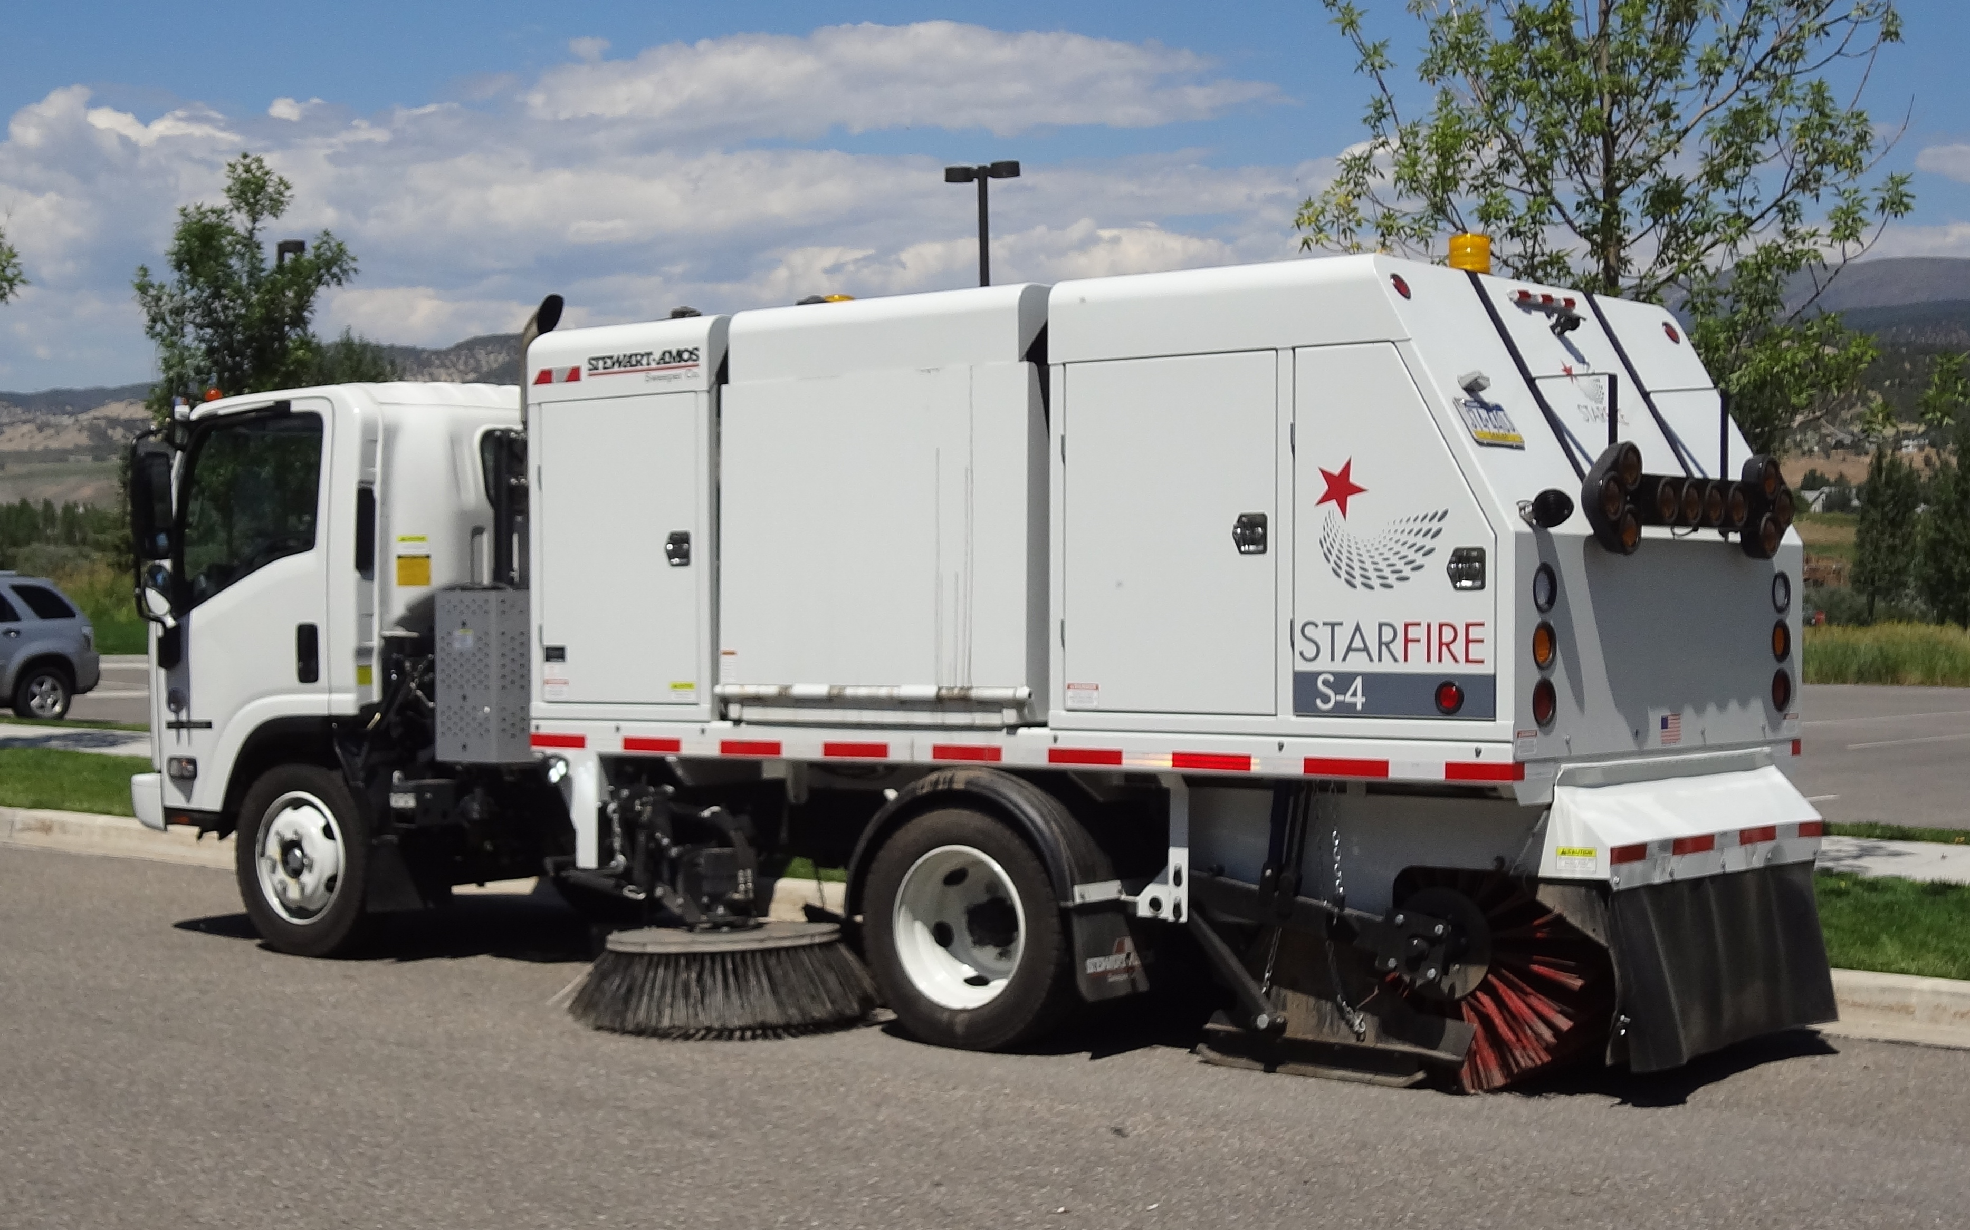

- BIG SWEEPER mounted on a small chassis. Equally effective cleaning streets, highways, construction sites and heavy road millings.

- NO CDL REQUIRED. Makes scheduling easier & lowers labor costs.

- HIGHLY MANEUVERABLE (like 3 wheel units) - Cab over chassis and short wheel base ensures tight turns in congested areas & cul-de-sacs.

- Travel between jobsites at highway speeds (65 mph).

- EXCLUSIVE 3 SHAFT ELEVATOR vastly improves component service life. Extends chain wear up to 4 to 5 times longer than 2 shaft designs.

- 10’ sweeping path, 4 yd³ hopper and up to 10’ variable dump.

- PM 10 Certified – Rule 1186 compliant.

- Extremely fuel efficient & remarkably quiet

- 44” hopper door ensures safer, quicker, more efficient debris disposal.
- Spring balanced, free floating broom automatically apply correct surface pressure & follow surface contours for a cleaner sweep.
- Easy to maintain/troubleshoot.
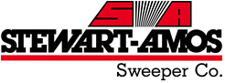

STARFIRE S-4 Added Value Features

INCREASED PRODUCTIVITY/PERFORMANCE FEATURES

- Tight turning radius provides excellent maneuverability in both congested areas and narrow streets/alleyways/cul-de-sacs.

- Excellent OPERATOR VISIBILITY to the front and sides ensures safer, more effective operations. Forward view from operator position to ground is less than 36”. Excellent visibility often eliminates need for expensive dual steering.

- NO CDL REQUIRED. Reduce your labor costs and make manpower scheduling easier.

- Unlike 3 or 4 wheel purpose built alternatives the S-4 can travel at highway speeds (up to 65 mph) making travel between job sites/disposal areas faster and more economical.

- Exclusive 3 shaft elevator maximizes upper chain support which extends component wear life expectancy up to 4 to 5 times longer than 2 shaft designs. A 3rd shaft doubles the number of chain adjustment points. This reduces routine maintenance and slashes repair costs. It also greatly improves debris pick-up performance by promoting unrestricted debris movement.

- Large 4 yd³ hopper dumps from frame level to 10’.

- Longer reach 44” hopper dump door ensures more efficient debris disposal and center loading of vehicles/trash receptacles. Extended reach maintains safer distance between sweeper and truck/receptacle. Eliminates need for hopper shifting which can cause stability issues in other models.

- Low overall machine height (less than 8.5’ with strobe light) ensures the S-4 can more effectively navigate tree lined streets.

- Main and gutter brooms are spring balanced & free floating. They automatically apply correct surface pressure & follow surface contours for a clean sweep. They do not require costly and maintenance intensive hydraulic or pneumatic components. No operator adjustments needed! Spring balanced & free floating brooms lasts longer & provide a cleaner sweep.

- Standard in-cab gutter broom TILT CONTROLS ensure easy broom adjustments to more effectively clean deeper, hard-to-reach cutters. This ensures better one-pass cleaning performance.

- THREE separate DUST SUPPRESSION CONTROL POINTS allow operator to focus on critical dust generation areas and ensure maximum dust free sweeping performance.

- 2 spray nozzles over each curb broom
- 4 front bumper mounted spray nozzles
- 4 stray nozzles on main broom/elevator

- DUST FREE SWEEPING provided by 3.6 GPM electric diaphragm pump and 200 gallon water supply. Pump is continuous run dry rated for longer service live.

- Optional main broom channeler ensures effective sweeping of light litter including leaves, straw and pine needles. Constructed of durable one piece, heavy duty steel, the channeler self-adjusts as the main broom wears. No operator or mechanic judgments required.

DURABILITY AND LOWER COST OF OWNERSHIP FEATURES

- Exclusive four “X” style lift scissors provide exceptional hopper stability when dumping wet, unbalanced or sticky debris. Twin hydraulic lifting cylinders incorporated into 4 lift scissor design equally distribute lifting force to all four corners of both the hopper and chassis frame. Two additional scissors eliminate risk the hopper, scissors or frame could bend or twist due to load imbalance or hydraulic issues.

- Elevator powered by heavy duty off-set hydraulic drive. Hydraulic motor and top elevator shaft connected via double #80 roller chain and sprockets with idler tensioning spring protection. Unlike direct drive designs that can place torque of the load generated by the elevator directly onto the shaft of the motor creating unnecessary stress, wear and expensive repairs, our off-set drive protects the motor from shocks and jarring impacts common during operation. It provides a more robust mounting system for connecting elevator drive shaft to the hydraulic motor. This insures longer service life and reduces risk of mechanical failure during critical operations. The spring idler helps reduce shocks directly on the motor shaft and the sprockets allow for elevator speed adjustment to various sweeping conditions.

- To maximize service life and minimize maintenance costs, elevator drag pans are constructed of abrasion resistant AR400 plate steel. Hopper walls are constructed of 10 gauge and hopper floors are constructed of 7 gauge hardened steel.

- Over-sized Tier 4 Interim Kubota 59Hp turbo-diesel auxiliary engine comes standard with high temperature/low oil pressure auto shutdown.

- OVERSIZED 45 gallon hydraulic reservoir ensures maximum performance and minimalizes overheating risks.

- All hydraulic motors equipped with case drains that protect shaft seals from excessive pressure and leaks. Protects the motor and seals. Minimizes maintenance, replacement and repair costs.

- To remove shock loading directly on the motor shaft and allow for elevator speed adjustment for various sweeping conditions, the elevator shall be driven by a hydraulic motor with power transmission to the elevator drive shaft through a double # 80 roller chain. Systems that place the torque of the load generated by the elevator directly onto the shaft of the hydraulic motor are unacceptable.

- The S-4 utilizes tandem cast-iron gear pumps which provide a constant flow of fluid power to all motors. Cast iron gear pumps are considerably more tolerant of heat and contaminants. They are far simpler and more economical to trouble-shoot repair and replace.

- The S-4 utilizes a simple electric over hydraulic valve system. It consists of a cast aluminum manifold with externally mounted universal fit valve bodies. A defective valve can be replaced in 10 minutes and are interchangeable with other manufacturers for lower costs and quick repairs.

- To make troubleshooting quick and easy, the hydraulic system incorporates built in hydraulic pressure monitoring gauges readable from the operators control panel in the cab.

- Simplified wiring is housed in a NEMA Class 4 box which is “weather proof” against dust and moisture. Numbered wiring is heat stamped on and will never wear off.

- Dump door cylinders connected to hopper door via a flexible joint that protects both in the event the door encounters something while opening. Protects both the cylinders and door minimizing maintenance and costs.

- Gutter brooms mounted to heavy duty 4” x 4” x .25” tube steel posts. Provide maximum support against impacts. Reduce maintenance costs.

- One piece main frame construction incorporates heavy duty 2" x 5" x 3/8" outer frame wall tubing. Unibody construction provides exceptional support to all components. It minimizes stress cracks and frame bending by distributing component and load weight across entire frame and chassis.

- Additional 8" C channel inner rail system interconnects with outer frame to further support and distribute weight of main broom, water tank and elevator assembly. Provides added support to back half of unit to prevent frame cracking or bending.

- Heavy duty front and rear steel canopies protect vulnerable internal components from the elements, vandalism and passing tree branches. Also tie together with the outer frame and inner C channel rail system to create an overall sturdier carriage platform.

- To protect itself from damage, the elevator automatically pivots up and over large fixed obstructions a minimum of 10". No operator judgment/attention is required.

- LED lighting produces greater illumination while consuming two thirds less power than incandescent bulbs.

- Wear component part numbers etched in all black painted metal parts for easier identification.

- All four hydraulic motors (2 gutter, 1 main broom and 1 elevator) are the same. Greatly reduces maintenance costs.

EASE OF OPERATION & OPERATOR SAFETY FEATURES

- All operating controls conveniently located in cab. Intuitive/dependable rocker switches control all functions. Control panel vertically mounted in front of the bench seat to prevent spilled liquids from contaminating the switches. For operator ergonomic comfort, the control box has dual action pivot points, UP - DOWN / LEFT - RIGHT, permitting operator to adjust box to better see the control switches. A console light provided for night operation. Large dial faces aid in effective operation.

- “EYES FORWARD” color camera safety system keeps operator facing forward versus constantly diverting attention to rear view mirrors. Dash board mounted 7” COLOR MONITOR (positioned slightly to right of operator’s forward view) provides operator with clear view of right side broom and rear bumper.

- One-Touch Sweeping allows the operator to preset sweeping functions. When activated all preset functions automatically activate. When deactivated, all preset functions deactivate. This minimizes operator involvement and promotes safer operations.

- When the unit is placed in reverse, the auto-pick-up in reverse feature is activated. All operating sweeping functions including: gutter, main brooms and elevator shut off and rise off the ground. The water also shuts off. When ready, the operator can activate the One-Touch Sweeping button to return everything to normal. Auto pick-up in reverse protects against component damage and makes for a cleaner operation.

- ALL LED LIGHTING means never a bad bulb. Provides greater assurance your units is operating safely and legally.

